1. **Technologies used in this application :**

* JDK 1.7
* Spring (Core, MVC) 4.1.6.RELEASE
* Spring Security 3.2.3.RELEASE
* Hibernate 3.6.9.Final
* HSQLDB 2.3.2
* Servlet API 3.1.0
* Ehcache 2.6.10
* Jackson 2.6.3
* JSON 20151123
* JSTL 1.2
* Jetty 9.2.7.v20150116
* Maven 3.0.3
* Eclipse 3.6
* Logback 1.1.3
* SLF4J 1.7.12

1. **Project Structure**

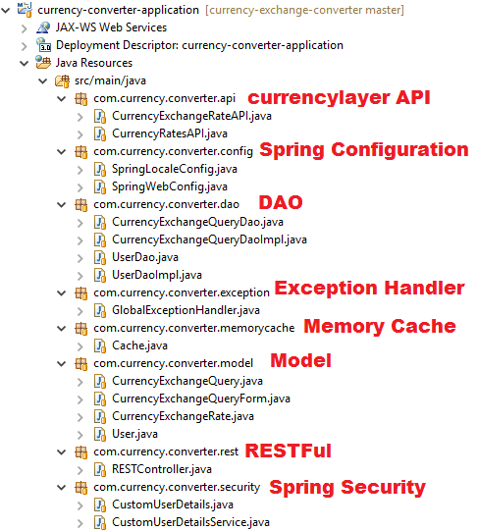

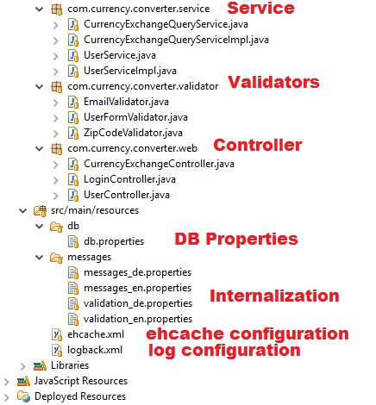

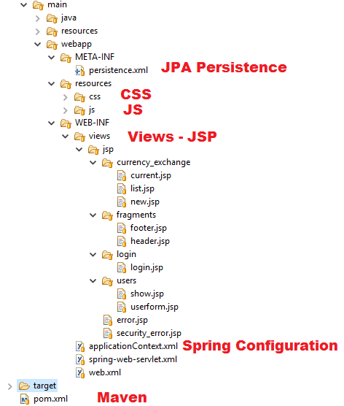

1. **Run application**

* Git Clone <https://github.com/migueldelprado/currency-exchange-converter.git>
* mvn package
* java -jar target/dependency/jetty-runner.jar target/*.war
* Go to <http://localhost:8080>

*Internet connection is requiered to run the application

1. **Configuration Ehcache**

* File /currency-converter-application/src/main/resources/ehcache.xml

1. **Configuration Memory Cache for API**

**private** **final** **static** **long** ***cacheTimeToLive*** = 200;

**private** **final** **static** **long** ***cacheTimerInterval*** = 500;

**private** **final** **static** Cache< String, HashMap< String, Double > > ***cache*** = **new** Cache< String, HashMap< String, Double > >( ***cacheTimeToLive***, ***cacheTimerInterval*** );

1. **RESTFUL**

/currency-converter-application/src/main/java/com/currency/converter/rest/RESTController.java

* **Get information about an user**
  + HTTP GET should be used
  + URL ${application-context}/restful/users/{id}
  + {id} - User ID
* **Add a new user**
  + HTTP POST should be used
  + URL ${application-context}/restful/users/add
  + {

"name": "Miguel",

"email": "miguel@example.com",

"dateOfBirth": 554774400000,

"password": "123456",

"street": "Strasse 2",

"zipCode": 81369,

"city": "Boston",

"country": "US"

}

* **Update an existing user**
  + HTTP PUT should be used
  + URL ${application-context}/restful/users/update/{id}
* **Get historical queries for an user**
  + HTTP GET should be used
  + URL ${application-context}/restful/currency_exchange/{id}
  + {id} - User ID

1. **Application running**

<http://currency-exchange-converter.herokuapp.com/>